DASHBOARD IMAGE AND EXPLANATIONS

SUMMARY
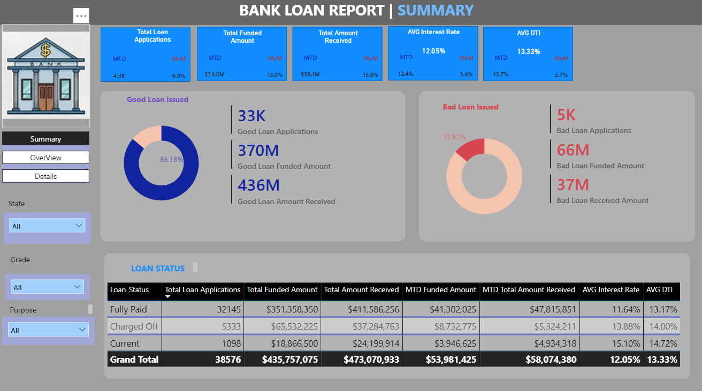

This Bank Loan Report dashboard delivers a high-level summary of the institution's lending performance, highlighting that 86.18% of total applications represent good, performing loans (totaling $370M funded and $436M received across 33K applications), while 13.82% are classified as bad or charged-off loans (accounting for $66M funded and $37M received across 5K applications). Across its total portfolio of 38,576 loan applications, the bank has funded $435,757,075 and collected $473,070,933, maintaining an overall average interest rate of 12.05% and an average Debt-to-Income (DTI) ratio of 13.33%. Key Month-to-Date (MTD) performance indicators show positive growth, with 4.3K MTD applications (up 6.9% MoM), $54.0M MTD funded (up 13.0% MoM), and $58.1M MTD received (up 15.8% MoM). Finally, the granular status breakdown reveals that high-risk, charged-off loans correspond with notably higher interest rates (13.88%) and higher DTIs (14.00%) compared to fully paid loans (11.64% interest rate and 13.17% DTI), while interactive left-panel slicers allow users to filter these insights by State, Grade, Purpose, and view level.

OVERVIEW
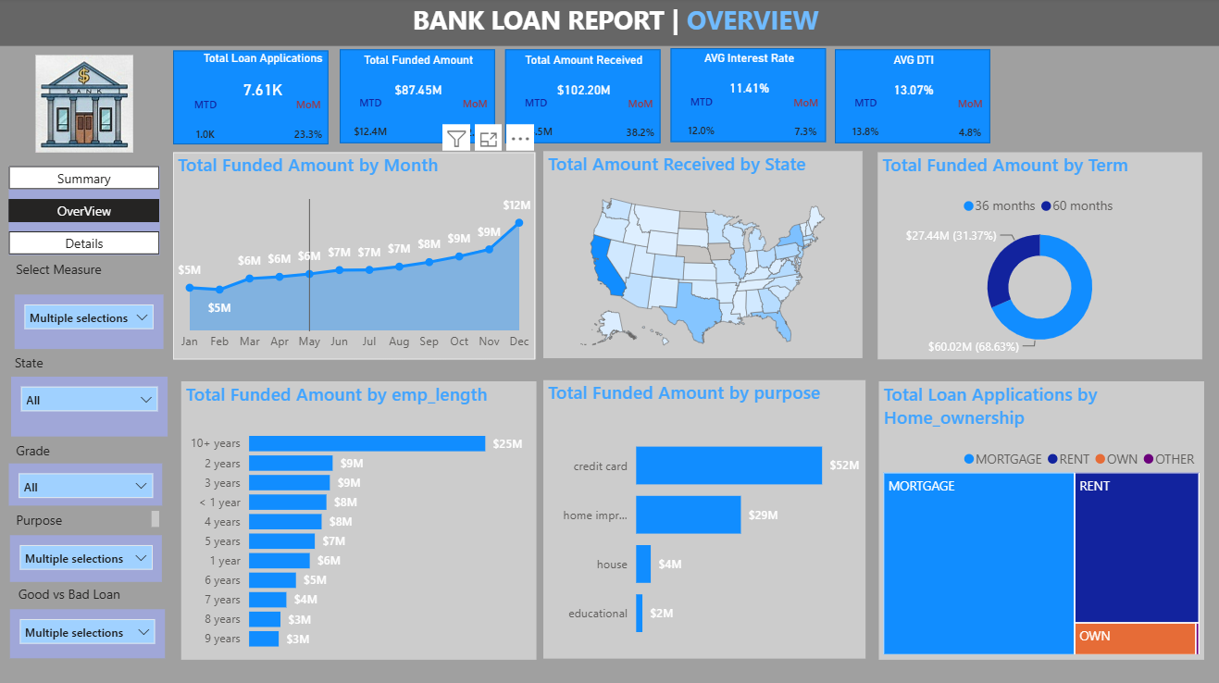

The Bank Loan Report Overview dashboard provides a comprehensive visual breakdown of key portfolio trends across time, location, and borrower demographics. Top-level performance metrics indicate strong growth, featuring 7.61K overall loan applications (1.0K MTD, up 23.3% MoM), $87.45M in total funded loans, and $102.20M in total collections (up 38.2% MoM), all while maintaining an average interest rate of 11.41% and an average DTI of 13.07%. Six core visualizations highlight key insights: monthly funded amounts trend upward consistently throughout the year from $5M in January to a peak of $12M in December; regional distributions show heavy concentrations in key states like California; and 36-month terms remain the primary choice for borrowers ($60.02M / 68.63%) compared to 60-month terms ($27.44M / 31.37%). Furthermore, borrowers with 10+ years of employment account for the largest share of funding ($25M), credit card consolidation serves as the primary loan purpose ($52M), and applicants are overwhelmingly concentrated in Mortgage or Rent housing categories. Interactive slicers on the left panel allow users to dynamically adjust all visualizations by measure, state, grade, purpose, or loan status.

DETAILS
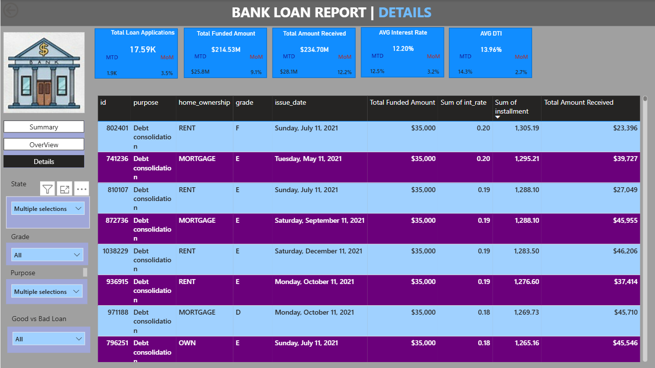

The Bank Loan Report | Details dashboard presents a granular, record-level audit table of individual loan accounts alongside key portfolio-wide performance indicators. Across the top banner, key metrics highlight a total of 17.59K loan applications (1.9K MTD, up 3.5% MoM), $214.53M in total funded amount ($25.8M MTD, up 9.1% MoM), and $234.70M in total amount received ($28.1M MTD, up 12.2% MoM), while maintaining an average interest rate of 12.20% and an average Debt-to-Income (DTI) ratio of 13.96%. The main detailed data table displays individual loan records sorted by payment installment amounts, showing specific account IDs, loan purposes (predominantly debt consolidation), homeownership status (such as Rent, Mortgage, or Own), credit risk grades (ranging from D to F), issue dates throughout 2021, funded loan amounts (e.g., $35,000 across visible entries), interest rates, monthly installment amounts, and total repayments received to date. Additionally, the interactive left navigation panel allows users to filter this detailed ledger across various parameters including State, Grade, Purpose, and Good vs Bad Loan classifications.

